Danger Signs When Pregnant

Call us right away if you:
- Feel dizzy.
- Have a fever or chills.
- Have a really terrible headache, or your headaches go on for days.
- You have any change in your eyesight – blurred vision, flashes of lights, or spots in front of your eyes.
- Your face or hands swell up.
- You gain too much weight too quickly.
- It's hard for you to breathe.
- You fall, suffer a blow to the stomach,
or are in a car accident.

Don’t wait. Call right away if you:
- Have any bleeding from your vagina.
- Have a sudden flow of water or if water leaks from your vagina.
- See a change in the discharge that comes out of your vagina.
- Have a sharp pain when you urinate (pee).

Later in your pregnancy, call us right away, day or night, if:
- You feel a big change in the way your baby moves, or if your baby moves less often.
- Your uterus tightens up more than
5 times in 1 hour, or more often than
every 10 minutes.
- You vomit or have a bad stomach ache, maybe with diarrhea. You may feel pain or pressure in your thighs or around your vagina.
- You have a lower backache, with pain or a dull pressure.
Other Services

Emergency Hospital

WIC (Women, Infant, Children Supplemental Nutrition Program)

Lab

Delivery Hospital

Childbirth Preparation Classes

Breastfeeding Help

Community Agencies



Welcome

to

Prenatal
Care

Pregnancy Services We Offer
We offer:
- Check-ups once a month or more often, the whole time you are pregnant.

- Tests to check your health and the health of your baby.

- Help finding resources for you, like WIC or food banks.

We can give you:
- Information on pregnancy, birth, breastfeeding, and baby care.
- Help with how to eat healthy foods while you are pregnant.

- Help with how to cut down or quit smoking, drinking, or using drugs.

- A place to discuss your family issues and needs.

Our Staff
(names, staff titles, photos?)

Help Us Give You the Best Care

- Be honest about your medical history and the way you live. These things may affect your pregnancy and your baby's health.

- Ask questions about what you don't understand.

- Follow advice given by the staff.
Let us know if you might not be able to follow it for some reason.

- Let us know if there is any change in your health.

Please…
  - Come to all of your appointments.

  - Arrive on time. Call us if you are going to be late.

  - Call 24 hours in advance if you need to cancel an appointment.

  - Tell us if your address or phone number changes.

  - Let us know if you have any ideas about making our services better.
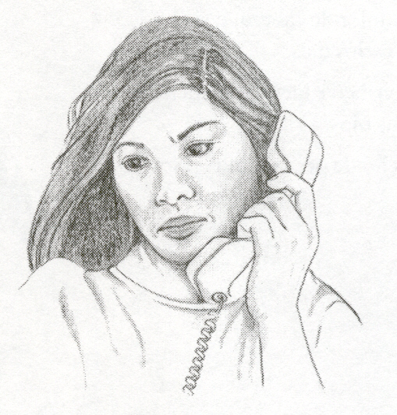
Client Rights to Good Care

We promise to:
- Treat you with respect.

- Make sure that what you say to us stays private. Your health care is just between you and us. We may need to report abuse or violence, so that you can get the help you need.

- Explain to you about what tests you need, and how we do things at this office.

- Answer any questions you might have about your care.

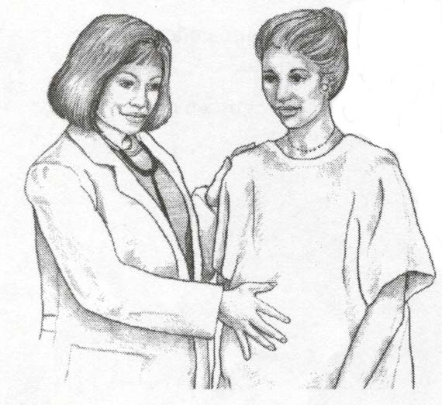

You have the right to:
- Take a look at your medical record with someone from our office.

- Help plan and make choices about your care while you are pregnant, in labor, or giving birth.

- Accept or refuse any care, treatment, or services.

