

Kim Saruwatari, M.P.H., Director
Cameron Kaiser, M.D., M.P.H., Public Health Officer

WORLD TB DAY - MARCH 24, 2019

“IT’S TIME – TO END TB”

“It’s Time - to End TB” was this year’s World TB Day theme. Tuberculosis (TB) is a disease that requires a global approach while implementing effective strategies at the local level.

According to the Centers for Disease Control and Prevention, TB infects one third of the world’s population. It is estimated that 2.3 million Californians are infected with TB. Preliminary data from the CDC National TB Surveillance System indicates that 9,029 TB cases were reported in the United States in 2018. The California Department of Public Health indicated that 2,091 active cases were identified in the State in 2018 compared to 2,059 for 2017. Riverside County’s case rate of 2.8 for 2018 exceeds the year 2020 national objective of 1.0 case per 100,000 populations. The number of cases per year has ranged from 52 to 65 cases. Case rates are reflected in Figure 1.

Figure 1

Profile of TB Cases

A review of the demographic characteristics of reported cases for 2018 indicates that 51% of the individuals were 55 years or older. Two cases occurred in children in the 0-4 years of age group, indicating recent transmission. The age distribution is depicted in Figure 2.

Figure 2
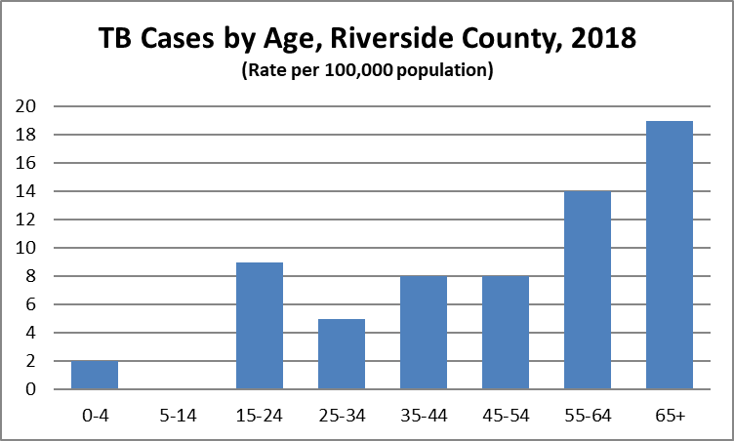

Seventy-four (74) percent of reported cases were non-US born. The majority of cases were from Mexico, United States and Philippines with 26, 17 and 10 cases respectively.

Although the majority of TB cases occurred in Western Riverside County, cases are distributed throughout the County. The geographic distribution is reflected in Table 1.

Table 1: N= 65
Geographic Area | Cases Reported
West | 30
Mid-County | 11
South | 4
East | 20

Important TB Control Strategies

A key strategy to move toward the control of tuberculosis is the early identification and appropriate treatment of individuals with active disease. The core regimen for pan-sensitive TB consists of INH, rifampin, PZA and ethambutol.

Patients with multiple-drug resistant TB (MDR-TB) require treatment for 18-24 months with appropriate medications based on the drug susceptibility studies. One MDR-TB case was identified in Riverside County in 2018 (refer to figure 3). MDR-TB is defined as TB disease that is resistant to at least isoniazid and rifampin, two of the most effective first line drugs. Extensively drug resistant TB (XDR-TB) refers to TB that is resistant to isoniazid, rifampin, a fluoroquinolone and a second-line injective. All patients on treatment for TB are assessed for risk for non-adherence by a Public Health Nurse. At risk patients are enrolled in the Public Health Directly Observed Therapy Program (DOT).

Figure 3
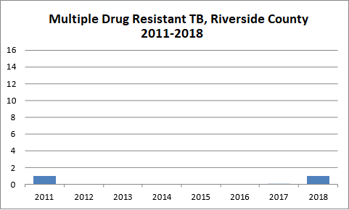

Changes in Requirements for Civil Surgeons

Effective October 2018, the Technical Instructions for TB screening by physicians designated by CDC as Civil Surgeons, require use of an Interferon Gamma Release Assay (QFT or T-spot).

Individuals applying for an adjustment of their immigration status who test positive, must have a chest x-ray taken. The Civil Surgeon must submit a report to Public Health. Individuals testing positive should be evaluated for treatment of latent TB infection, after active TB is ruled out.

Reports may be submitted to Disease Control by faxing the information to (951) 358-7922, or through the California Reportable Disease Information Exchange (CalREDIE). Providers wishing to enroll in CalREDIE should contact Disease Control at (951) 358-5107 or e-mail bcole@ruhealth.org.

Moving Toward TB Elimination

Although progress has been made at the national, state, and local levels in the fight against tuberculosis, the disease continues to impact individuals, their families and communities throughout the world.

The recognition of March 24 as World TB Day highlights the importance of thinking globally while acting locally to control tuberculosis. Collaboration between Public Health, the medical community and other key partners is essential for the control of this disease.

Tuberculosis is reportable to Public Health, Disease Control within one day of identification. Phone: (951) 358-5107 Fax: (951) 358-7922. TB may also be reported through CalREDIE.

