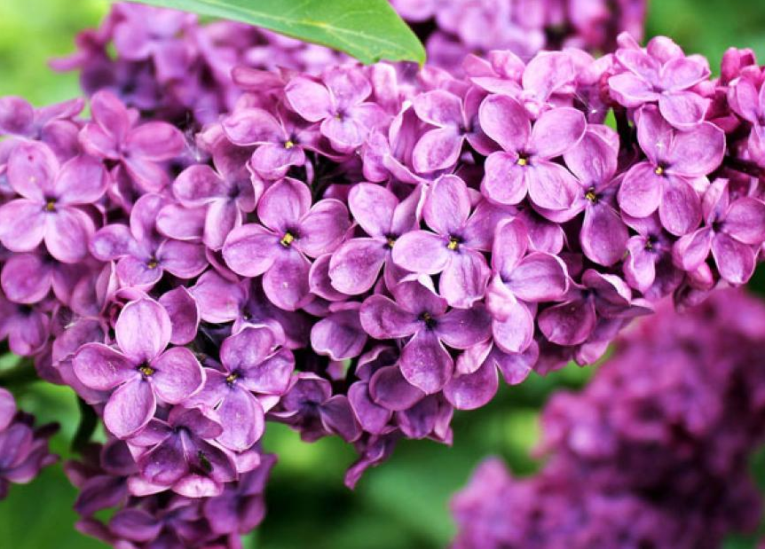
April 2023
INDIO Peer Support & Resource Center 44199 Monroe Street, Suite B
Indio CA 92201-Phone: 760-863-7067
Monday  3 | Tuesday  4 | Wednesday  5 | Thursday  6 | Friday
12:00-1:00 Planning for  Success WK 2  1:30-3:00 Coping Thru  Creativity | 12:00-1:00 Lunch & Learn  1:30-3:00 Social Skills  Recovery Games | 12:00-1:00 M.O.R.E. WK 7  1:30-3:00 WELL WK 7 | 12:00-1:00 Lunch & Learn  1:30-3:00 Taking Action  to Anger WK 1 | 7  12:00-3:00 Recovery Activity
10 | 11 | 12 | 13 | 14
9:00 – 10:00 Morning Reflections  10:30-11:30 Planning for  Success WK 3  12:00-1:00 Lunch & Learn  1:30-3:00 Coping Thru  Creativity |  |  | 9:00-10:00 Morning Reflections  10:30-11:30 Wellness Thru  Fitness  12:00-1:00 Lunch & Learn  1:30-3:00 Taking Action  to Anger WK 2  9:00-10:00 Morning Reflections  10:30-11:30 Exploring  Meditation  12:00-3:00 Recovery Activity
17 | 18  9:00 – 10:00 Morning Reflections  10:30-11:30 WHAM WK 2  12:00-1:00 Lunch & Learn  1:30-3:00 Social Skills  Recovery Games | 19  9:00-10:00 Morning Reflections  10:30-11:30 M.O.R.E. WK 1  12:00-1:00 Lunch & Learn  1:30-3:00 WELL WK 8 | 20 | 21
9:00 – 10:00 Morning Reflections  10:30-11:30 WHAM WK 3  12:00-1:00 Lunch & Learn  1:30-3:00 Social Skills  Recovery Games  9:00 – 10:00 Morning Reflections  10:30-11:30 Planning for  Success WK 4  12:00-1:00 Lunch & Learn  1:30-3:00 Coping Thru  Creativity |  | 9:00-10:00 Morning Reflections  10:30-11:30 M.O.R.E. WK 2  12:00-1:00 Lunch & Learn  1:30-3:00 WELL WK 9 | 9:00-10:00 Morning Reflections  10:30-11:30 Wellness Thru  Fitness  12:00-1:00 Lunch & Learn  1:30-3:00 Taking Action  to Anger WK 3  9:00-10:00 Morning Reflections  10:30-11:30 Exploring  Meditation  12:00-3:00 Recovery Activity
24 | 25 | 26 | 27 | 28
9:00 – 10:00 Morning Reflections  10:30-11:30 Planning for  Success WK 5  12:00-1:00 Lunch & Learn  1:30-3:00 Coping Thru  Creativity | 9:00 – 10:00 Morning Reflections  10:30-11:30 WHAM WK 4  12:00-1:00 Lunch & Learn  1:30-3:00 Social Skills  Recovery Games | 9:00-10:00 Morning Reflections  10:30-11:30 M.O.R.E. WK 3  12:00-1:00 Lunch & Learn  1:30-3:00 WELL WK 10 | 9:00-10:00 Morning Reflections  10:30-11:30 Wellness Thru  Fitness  12:00-1:00 Lunch & Learn  1:30-3:00 Taking Action  to Anger WK 4  9:00-10:00 Morning Reflections  10:30-11:30 Exploring  Meditation  12:00-3:00 Recovery Activity
Group Descriptions
Coping Through Creativity—this group will support individuals in the exploration of creativity as a wellness tool. This could include things such as journaling, coloring, mandalas, and vision boards and should explore all types of creative outlets.
Exploring Meditation/Relaxation—this group will focus on learning, practicing, and using relaxation and meditation techniques to support your wellness.
Lunch and Learn—bring your lunch and participate in discussion with your peers to support your wellness and recovery through the combined wisdom, knowledge and mutuality.
MORE - My Ongoing Recovery Experience— this group offers education and guidance on essential recovery topics that will help you successfully manage your recovery from substance abuse and/or mental health challenges.
Planning for Success (WRAP)—Planning for Success is an organized way for you to list all the things you do, have done, or would like to try to help yourself feel better, get well and stay well.
Social Skills and Recovery Games—this group provides participants the opportunity to engage with other community members, in a fun and interactive way that increases social skills and natural supports.
Taking Action to Manage Anger—this group will assist individuals in exploring the causes of anger, assist in the development of anger control tools and anger control plan, explore how to identify and challenge beliefs and thinking patterns that contribute to anger.
WELL - Wellness and Empowerment in Life and Living—this group is designed to assist individuals in finding and continuing wellness in all aspects of daily life. This groups uses holistic approach to promote mental, physical, social, financial, spiritual and general wellness.
Wellness Through Fitness—this group assists individuals in exploring how physical wellness can support their mental health wellness goals. This could include discussions around the benefits of diet and nutrition on wellness, exploring various types of exercise including but not limited to yoga, walking, etc.
Whole Health Action Management (WHAM)—this group assists participants in creating new health habits with the focus on developing a healthy mind and body.

